Dynamic Mask Shifting Lithography for OFML

Sunghwan Shin, Jisung Jang, Sangkwon Han, Wook Park*

School of Electrical Engineering and Computer Science, Seoul National University
E-mail: wook.park@multiplexon.com

Abstract
OFML(Optifluidic Maskless Lithography) has benefitted the method of microfluidic particle generation for drug delivery, LED packaging and controlled fluidic assembly of microstructures. While high throughput particle generation is of the most importance for realization of a practical system, high throughput system requires low magnification objective lens in the curing process for its wider field of view. DMD pixel size sets the limit for smallest curable pattern in the OFML system, and this leads to a degradation of the quality of particle generation especially when a low magnification lens is used. Here we present a method for high resolution microstructure generation using dynamic mask shifting lithography.

Keywords: English(한글), English(한글), English(한글), English(한글) (최대 5개 이하)

1. Introduction
optical lithography technique for microfluidic platform has evolved along with the need for precise shape control of biomaterials used for drug delivery carrier, hydrogels for tissue engineering and biomolecule analysis[doyle, langer]. While photomasks for conventional optical lithography was used for precise pattern formation[doyle], DMD masks also provided several advantages over fixed photomasks with the ability to dynamically switch between each curing process[OFML, uSL].
Along with the advantages of DMD mask, the drawback of DMD comes from the resolution limit coming from the pixel size. DMD is typically 1024 by 764 pixels where pixel size is around 13.6um. DMD pixel size of 13.6um corresponds to 3.4um on the generated micro particle when 4x magnification objective lens is used for projection optics. As lenses with wider field of view are preferred for batch processes in high throughput system, low magnification lenses typically serve this purpose. However, low magnification lenses suffer from the resolution limit as the number of pixels assigned to a single pattern is limited by the lens.
In the field of projection display where DMD has been widely used, several methods to overcome the resolution limit of DMD have been suggested. Wobulation, which utilized shift projection using a single DMD has several advantages in terms of cost and easy implementation. In this paper we present a method for higher resolution lithography using mask shifting(wobulation) with OFML.
2. Experiment
2.1 Experimental method
2.1.1 UV lithography Process
Photocuable resin(NOA 81 or PEG) was used for pattern formation, pattern was cured on our OFML setup(ref) using 4x objective lens. Photocurable resin was injected between two sandwiched slide glasses separated with a 30um spacer.
Single pixel on DMD (D4100) has a mirror pitch of 13.6um which corresponds to 3.4um pixel pitch on cured pattern. Mask shifting was achieved using precise stage shifting, and the stage was controlled using stepper motors (SCAN IM, Marzhauser) with a resolution of 0.05 um.
2.1.2 Mask Generation
Two low resolution masks were generated using MATLAB from the original high resolution mask. High resolution pattern is reconstructed using two sub masks (A,B masks), half pixel shifted to each other. Reconstructed mask on Fig. 2 (a) shows that most of the details can be recovered using mask shifting method.
2.1.3 Stage shifting
Mask shifting lithography can be performed either in a two-step curing process or multiple-step curing process. Two-step process performs UV curing with A mask, following half-pixel stage shift and B mask curing step.
Multiple-step curing performs UV curing with stage shifting simultaneously between A mask position and B mask position. Stage was programmed to shift at varying rates between two sub mask positions during the UV curing process, synchronized with DMD mask changes.
Stage control software was written and used to set the shifting speed of the stage. Stage shifting frequency was set from 1 cycle per second to 30 cycle per second.

2.2 Results
2.2.1 Two-step mask shifting
Single step UV curing was performed and compared with two-step mask shifting process. After the initial curing step, stage was shifted 1.7um in both horizontal and vertical directions following second curing step. Fig. 2(b) shows single step lithography patterns with visible pixels on the left and two-step mask shifting lithography patterns reconstructing higher resolution pattern on the right. Comparing reconstructed mask on Fig. 2(a) and two-step mask shifting pattern on Fig. 2(b) right, it is observed that mask shifting lithography successfully patterns the expected structure.
2.2.2 Fast mask shifting
Stage was shifted at the rate of 30 cycles per second, synchronized with DMD mask change. 1 Cycle consists of 2 UV curing step. Compared with single cycle lithography process, fast mask shifting showed smoother pattern structure as given in fig. 3.

3.Conclusion
We presented a dynamic mask shifting method to overcome the resolution limit of low magnification lens in OFML system. Two step mask shifting method showed better pattern resolution as expected compared to single step lithography process. Fast mask shifting also demonstrated smoother pattern formation compared to two-step lithography process. Using this method, high throughput particle fabrication system can utilize low magnification lens for high resolution pattern formation.

Acknowledgment

References
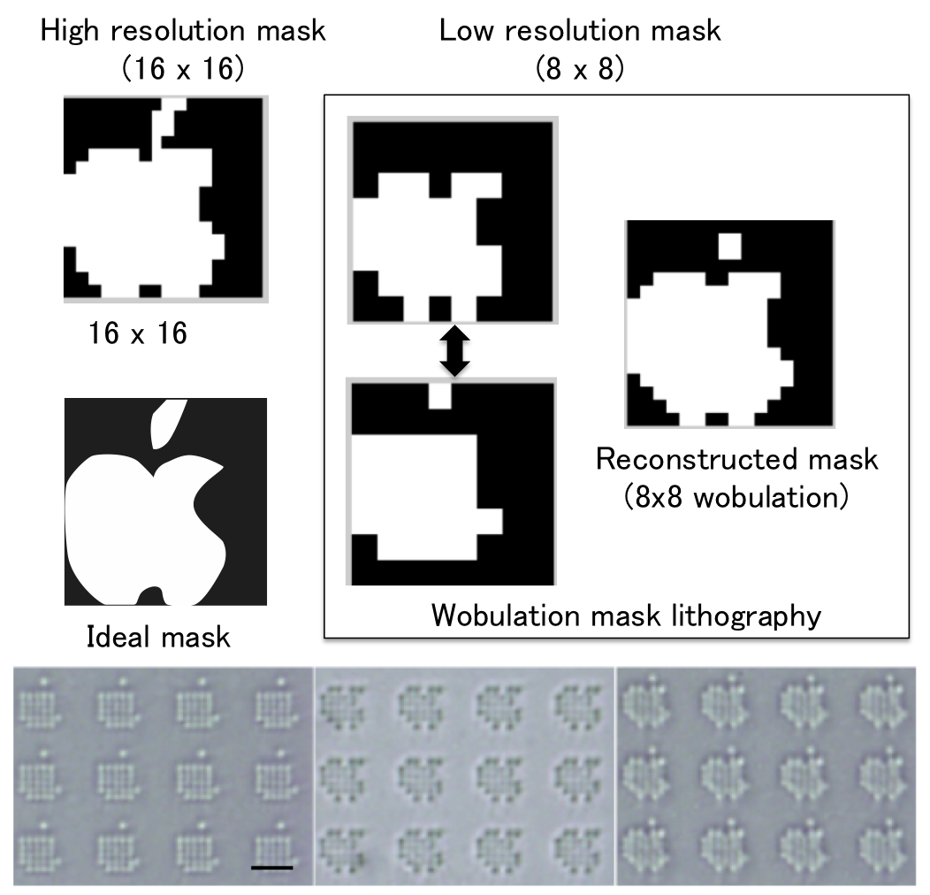
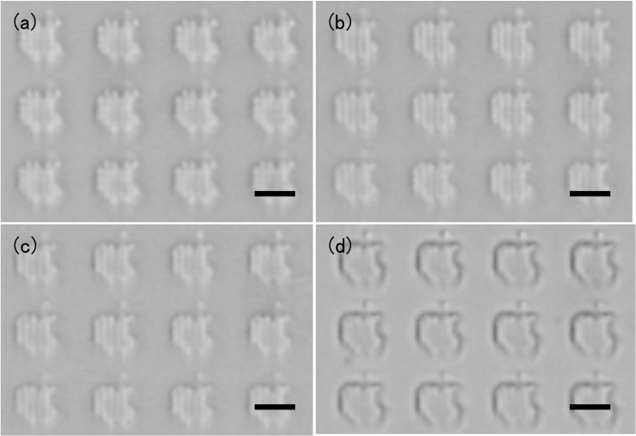
1. T. Tsuchiya, O. Tabata, J. Sakata, Y. Taga, Journal Specimen Size Effect on Tensile Strength of Surface Micromachined Polycrystalline Silicon Thin Films, J. Microelectromech. Syst. 7, 106 (Dec. 1998).
2. S. Senturia et al., Perspectives on MEMS Past Conference and Future: the Tortuous Pathway from Bright Ideas to Real Products, Transducers‘03 Conference, Boston, 10 (June, 2003).
3. M. Crichton, Book title, Harper Collins Publishers, Book Inc., New York, 2002.

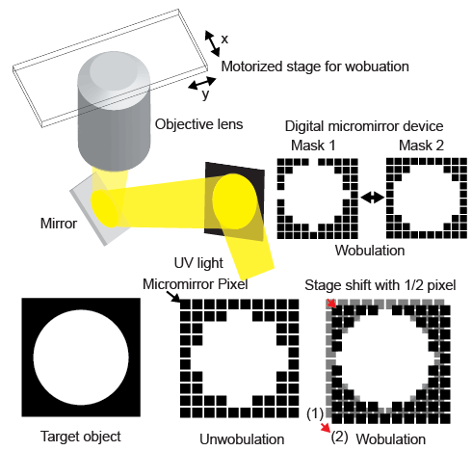

Fig. 1. OFML with mask shifting schematic.

Fig. 2. (a) Mask generation schematic (b) Reconstructed pattern using mask shifting lithography. (scale bar: xx um)

Fig. 3. Comparison of lithography pattern using two step mask shifting and Fast mask shifting (scale bar: xx um)

